The Little Shoemaker
https://www.youtube.com/watch?v=fEUwBMThY1w
Year 3 Home Learning Task
Watch the video The Little Shoemaker; a film about a shoemaker called Mr Botte. He makes and sells unusual shoes and business is good. However, the little shoemaker's life is about to change... a new shoe seller is in town and he will do anything to gain business. Mr Botte's business starts to fail. How will he cope?

Your task:
Monday Watch the film
- Design a poster advertising Mr Botte’s shoe shop.
You will need to use persuasive language to encourage lots of customers.

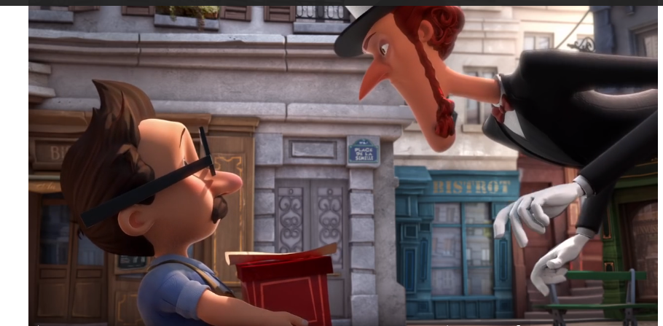
- Create some dialogue between the two characters – what are they saying to each other?

Tuesday 1. Design a pair of magic shoes. Draw and label each of the features of the shoes.
- Write some instructions on how to make the shoes.

