Old Bear by Jane Hissey
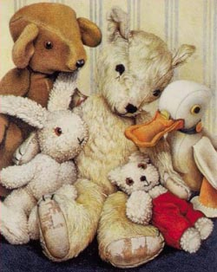
Bramwell Brown was sitting with Duck, Rabbit and Little Bear, when he suddenly remembered someone who wasn’t there.
“I do miss Old Bear,” he said, “I wish he could be here with us.”

A long, long time ago Old Bear was carefully put in a box. Then he was taken up a ladder to the attic.

“The children’s games were a bit too rough,” explained Bramwell “Old Bear was getting worn out.”

“I miss him too,” cried Little Bear. “Let’s go and get him!”

“What a marvellous idea!” said Bramwell Bear.

“We don’t have a ladder,” said Duck.

“We’ll make a tower of bricks,” cried Little Bear thoughtfully, “and climb up to rescue Old Bear”.

The toys collected wooden blocks and piled them up one on top of another.

The tower grew taller and taller. Little Bear was right on top when the tower began to wobble.

“Look out!” he cried, “I’m coming down!”

CRASH!

The tower collapsed all over the floor. “I don’t think you meant to come down that fast!” said Bramwell Brown.

(Page 1)

“Let’s make ourselves into a tower,” suggested Duck. “We won’t be as wobbly as bricks.”

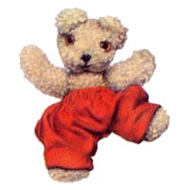
Little Bear held onto Rabbit’s ears and Rabbit hopped onto Duck’s head. Duck stood on tiptoes and stretched up as far as he could.

The he wobbled….
And Rabbit toppled…
And Little Bear tumbled…
Right on top of Bramwell Brown.

“Sorry,” said Duck, “perhaps that wasn’t such a good idea.”
“Not one of your best.” Replied Bramwell.

“I KNOW!” cried Rabbit, “We’ll bounce on the bed to get there.”
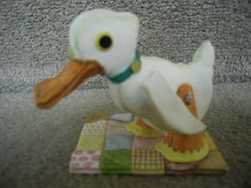
They began to jump;
up and down
up and down
up and down.

But still they couldn’t reach the trap door in the ceiling.

Duck looked very sad.

“We’ll never rescue Old Bear,” he sighed “He’ll be so lonely up there on his own.”

But Little Bear had an idea…

“I know how to get to the attic,” he said to Bramwell Brown.

He pointed to a very tall plant in the corner of the room.

“I’ll climb this,” he explained, “then jump into the attic and rescue Old Bear.”
(Page 2)

