**Maths**

Number: Year 1 division & consolidation. Place Value to 100 Year 2 Division. Statistics. Year 1 Geometry: Shape and consolidation, Year 2 :properties of shape. Year 1 Fractions and Consolidation, Year 2 Fractions,

Measurement: Length & height.

**English**

Guided reading sessions – **Tilly and the Time Machine by Ade Edmondson.**

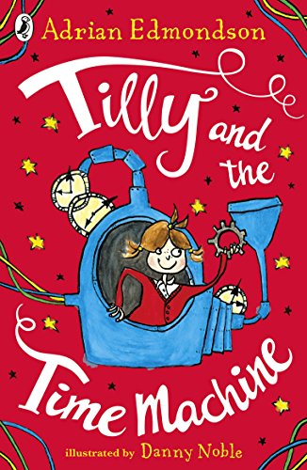

Phonics and Spelling

Use conjunctions in own writing

Grammar skills appropriate for year group

Handwriting, letter formation and joined

Comparing poems, rhyme, performing poems, poetry using imagery, adjectives, word play

Oliver Jeffers Lost and Found and Stuck – expedition lists, sequencing images, writing a recount and retelling stories

**Science**

Identifying animals

Grouping animals into categories

Identifying carnivores herbivores and Omnivores

Food chains

Naming sources of food for humans and animals

Explorers Term 3:

How should we treat animals? Under the Ocean: Responsibility, beauty, creativity

**Geography**

We are Explorers naming

and locating the five

oceans.

Use simple compass

directions

and locational and

directional language

We are learning to

use basic geographical

vocabulary to refer to

physical features

including beach, coast,

cliff, sea.

**Computing**

Digital literacy – coding with Beebots, touch typing and internet safety

**RE**

**Judaisim**

Does celebrating Chanukah make Jewish children feel closer to God?

**Art & DT**

* Collecting different textures
* Designing and making a clay frog
* Sea Collages and paintings
* Making and testing boats.

**PSHE & Citizenship**

Living in the Wider World – Money Matters

**PE**

Wiltshire Cricket - Chance to Shine KS1 Delivery - Winter 2019/20