**Maths**

**Counting, Adding and Subtracting, Space and Shape – 2D shapes, Measures,** Number and Place Value

Using number lines and 100 squares

Standard Measurement – length, capacity, weight

**Science**

Seasonal changes

Naming the seasons

Describing them, how they are different

How humans and animals are affected by the seasons

How the day length is affected by the seasons.

**English**

Phonics , spelling, grammar and punctuation relevant year group expectations.

Non- fiction and Information texts about animals in winter Seasonal rhymes

Sequencing and captions

Christmas themed visual literacy

Letters to Father Christmas

Recognising and joining in with predictable phrases/ recurring language

Texts:

The Secrets of Winter by Carron Brown

Books / posters about Samuel Pepys, Guy Fawkes

London’s Burning

Nursery and Seasonal rhymes

Monty the Christmas Penguin

The Jolly Pocket Postman by Janet and Alan Ahlberg

Explorers Term 2:

Are the best things in life free?

Key concepts: Friendship, faith, loyalty.

**RE**

Understanding the World: INCARNATION.

Why does Christmas matter to Christians?

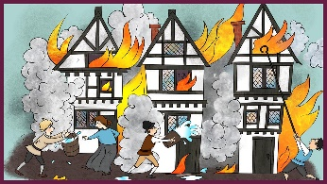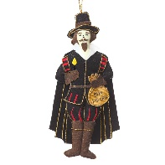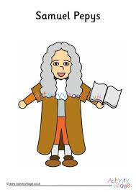

**PE**

Developing skills – safety during PE lessons.

**History**

Bonfire Night and The Great Fire Of London

Should we still celebrate Bonfire Night?

Did the Great Fire make London a better or worse place?

**Computing**

Programming, algorithms and debugging.

**Christmas Songs and Nativity**

Children use their voices expressively and creatively by singing songs and speaking chants and rhymes

Art

Shape, abstract art, colour mixing and craft, printing, drawing and experimenting with media. We will look at the work of the following artists, Louis Wain, Ila Bolowsky, Wassily Kandinsky and Renata Bernal

**PSHE**

Jigsaw – Changing Me