West Ashton Church of England

Voluntary Aided Primary School

29 Bratton Road

West Ashton

BA14 6AZ

Telephone: 01225 754354
Email: admin@westashton.wilts.sch.uk

Newsletter ^{16th} March 2018
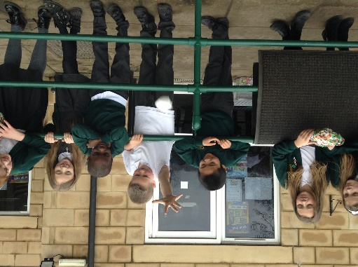
Message from Mrs Huxham
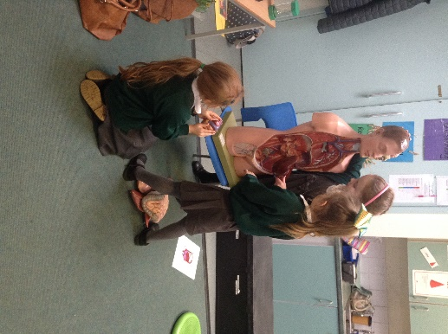
Firstly, we would like to welcome Ms Pam Pugh who has joined our team as the new catering assistant.
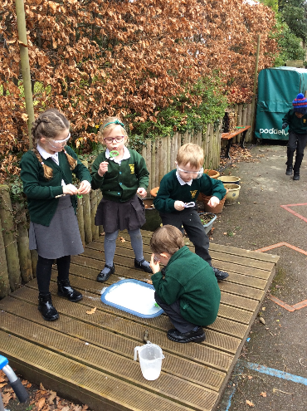
We have had an amazing science week this week, Robins have been designing boats and investigating floating, sinking and bubbles, Skylarks have been investigating the human body and Eagles have been investigating forces where they had great fun with an experiments to find the right material to prevent a tomato being squashed, as you can see from the photo.

Drop-off: Thank you to all those parents who have supported us with our new morning playground routine, may I remind you that if you need to leave your child unattended on the playground please put them into breakfast club in order to keep all the children safe in school.
Collections: please remember that school finishes at 3pm, please collect your child from the playground. If you are going to be late please contact the school office and we will keep your child in the office until you arrive.
Due to allergies our school has a NO NUT policy, please ensure that your child does not bring nuts in their lunch box.
Reminder:
- end of term is Wednesday 28th march, finishing at 3pm.
- Sunday 25th March FOWAS Easter egg hunt in the school grounds at 2pm

Gardening club:
Mrs Locke has kindly volunteered to run a gardening club next term; she has asked if anyone has any of the following they could donate to the school:
- Broken bricks/tiles
- Plant pots
- Corrugated cardboard
- Bits of drainpipes
- Plastic bottles
- Spare rolls of turf
We look forward to seeing the good work that the club will produce.

REMINDER:…Book Fair – 21-28th March
WE are holding a Book Fair in Roblarks classroom after school from 3.00pm to 3.30pm every day from Wednesday 21st to Tuesday 27th March. There are plenty of books to buy and we raise money for books for school as well.
I hope you have a great weekend.

Debby Huxham
Certificates
The certificates and awards given in this week’s Celebration Assembly were as follows:
Class Certificates – w/e 16/03/2018 Hayden Ingram-Tucker, Nevaeh Ricaud, Jonathan Cruikshank
Good Work Certificates – w/e 16/03/2018 Samuel Windel, Henry Montacute, Cherry Cao
Kindness Certificates – w/e 16/03/2018 Olivia Locke, Beth Williams, Alexa Lux

Bronze badges – w/e 16/03/2018 Noah Heywood, Paddy Rooney, Henry Montacute
Silver badge - w/e 16/03/2018 Max Roberts, Abigail Squires, Lacey Welch, Oakley Noad, Logan Bell, Jasmine Millar, Justin Chen
A big well done to all these children.
A reminder of the house point targets:
½ to Bronze 25 points Gold 250 points
Bronze 50 points Platinum 500 points
Silver 100 points Diamond 800 points

Key Dates:
- Sunday 25th March – Palm Sunday Service 10.30am St John’s Church WA
- Sunday 25th March – Easter Egg Hunt – WA School Grounds – 2.00- 4.00pm
- Thursday 29th March – TD Day
- 30th March – 13th April – school holiday
- Sunday 1st April – Easter Sunday Service – 10.30am St John’s Church WA
- Wednesday 25th April – Academy Council Meeting 6.00pm

