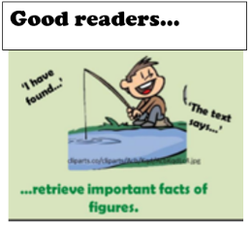
Title: Retrieve

Old Bear page 2

- Which word tells you that Rabbit jumped onto Duck’s beak?
- Who did all the animals collapse on top of?
- What was Rabbit’s idea to get to the trap door?
- What did Little Bear notice in the corner of the room?.
- Using the illustration, write down two things that you can see happening.

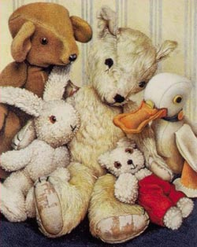

Extension- Write three retrieval questions about page 2 to show your understanding.

