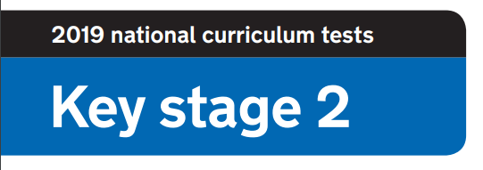

**2020 National Curriculum Tests**

**KS2 Lockdown SATs**

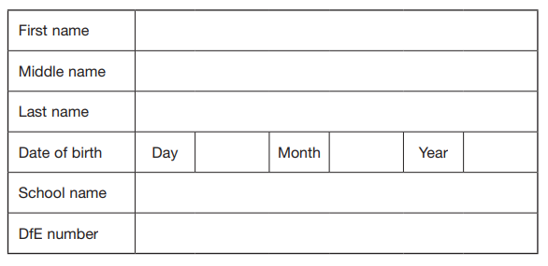



**Questions and Answers**

You have until ***4pm Thursday 14th May*** to complete the booklet and send me your answers and times.

Work as quickly and as carefully as you can.

If you cannot do a question, go on to the next one. You can come back to it later, if you have time.

If you finish before the end, go back and check your work.

**Marks**

The number under each question at the side of the page tells you the number of marks available for each question.

All scores will be converted to a standardised score to determine whether you are ***‘Working Towards’, ‘Working At’*** or ***‘Working Above’ the Year 6 Standard.***

**Results**

You will be notified of your results once all papers are marked.

All participants will be awarded with a **‘Lockdown SATs’ certificate.**

Paper 1: How well do you know your school?

1. What does it say on the board next to the arch to the outside door in Voyagers?

**1 mark**

1. How many numbers are printed on the playground outside Voyagers?

**1 mark**

1. What 3 school values can be found on the rocket display by the door to the office?

**3 marks**

1. What 2 things are on the board in the hall behind the laptop?

**2 mark**

1. What does the poster outside the KS2 toilets say?.

**1 mark**

1. How many PLT photos are there on the way to the hall?

**1 mark**

1. What art work is displayed above the photocopier outside Voyagers?

**1 mark**

1. What can be found above the Voyagers sink?

**1 mark**

1. How many radiators are there in Voyagers classroom?
2. **mark**

10. What name can be found on the classroom door?

**1 mark**

Paper 2: How well do you know chocolate?

**Can you name the chocolate bars below?**

**You will be awarded 1 mark for each correct answer.**

|  |  |  |  |
| --- | --- | --- | --- |
|  |  |  |  |
|  |  |  |  |
|  |  |  |  |
|  |  |  |  |
|  |  |  |  |
|  |  |  |  |
|  |  |  |  |
|  |  |  |  |

Paper 3: Where’s Wally?

**Timed paper. You will need a stopwatch.**

**Time how many seconds it takes to find Wally.**

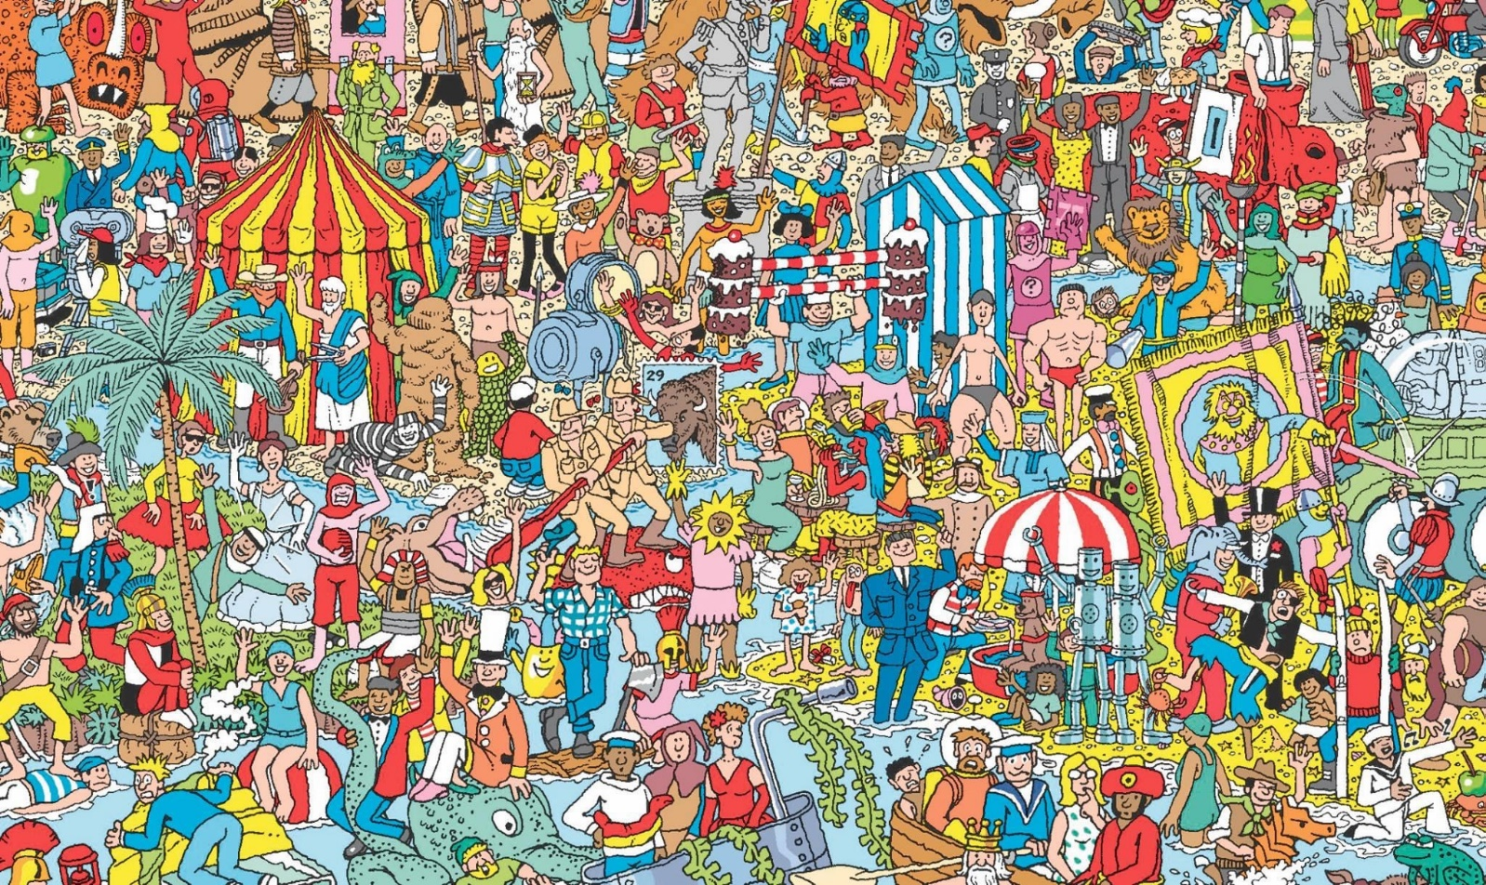

**The times will be ordered and you will receive up to 10 marks.**

Paper 4: How well do you know the staff?

**Match the boxes to make the sentences true**

**1 mark for each correct answer**

represented the school in high jump – and came 1st!

Mrs Meehan

lived in Germany for 10 years

Mrs Bayford

met Mr Blobby

Mrs Squires

ran the Bath Race for Life

Mrs Bowman

sang on stage with the Proclaimers

Mrs House

took her class to meet the Queen

Miss Bridewell

kissed Gordon Ramsey!

Mrs Fox

speaks fluent Kiswahili

saw David Beckham score from the half way line

Mrs Perrin

sky-dived in New Zealand

Mrs Blake-Thwaite

has swam with turtles in the Great Barrier Reef

Mrs McNally

Mrs Huxham

had a photo in Bella magazine with Nick Berry singing together

Mrs Brown

Mrs Pugh

has been on 8 hot-air balloon rides

met the actor Anthony Head

Mrs Bristow

Paper 5: Scavenger Hunt

**Timed paper. You will need a stopwatch.**

**Starting in the room of your choice, ask a member of your household to time how long it takes to find the objects below. You can find the items in any order. Submit your time and if possible a photograph of the objects found. Add a 10 second penalty for any objects not found.**

**FIND THE FOLLOWING OBJECTS:**

* An unused toilet roll
* An item of clothing that is the colour you would get if you mixed blue and red together
* An item of clothing that has at least 4 buttons on
* A pen, pencil or crayon that is the top colour of a rainbow
* The word ‘**SCHOOL**’ - look in a book, magazine or newspaper
* Your school jumper
* A dessert spoon
* A school photograph of yourself
* Your favourite book
* Something that will hold everything you’ve found

**The times will be ordered and you will receive up to 10 marks.**

Paper 6: Spelling Test

**You will need a member of your household to read the spelling list attached separately.**

1. ____________________ **1 mark**
2. ____________________ **1 mark**
3. ____________________ **1 mark**
4. ____________________ **1 mark**
5. ____________________ **1 mark**
6. ____________________ **1 mark**
7. ____________________ **1 mark**
8. ____________________ **1 mark**
9. ____________________ **1 mark**
10. ________________ **1 mark**

Paper 7: Art

There

**‘Everyday object’ art challenge. Select an object to include in a drawing. Your drawing will be assessed by a panel of adjudicators and given a score out of 5 for each area: creativity, artistic style and humour!**

**15 marks**

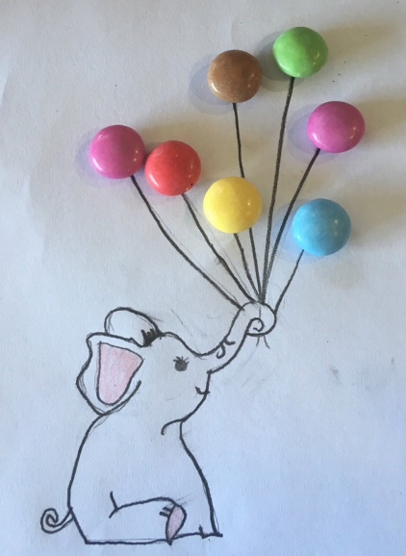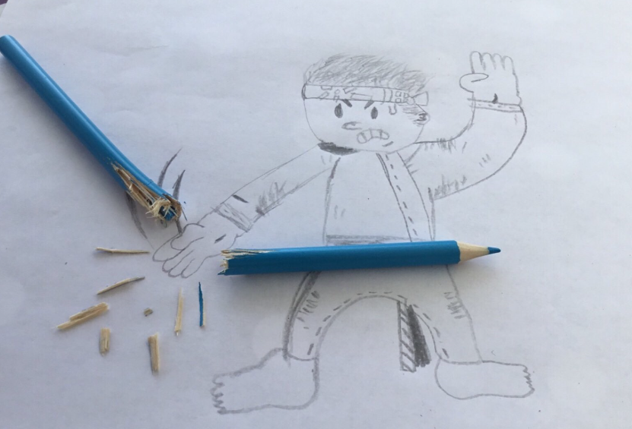

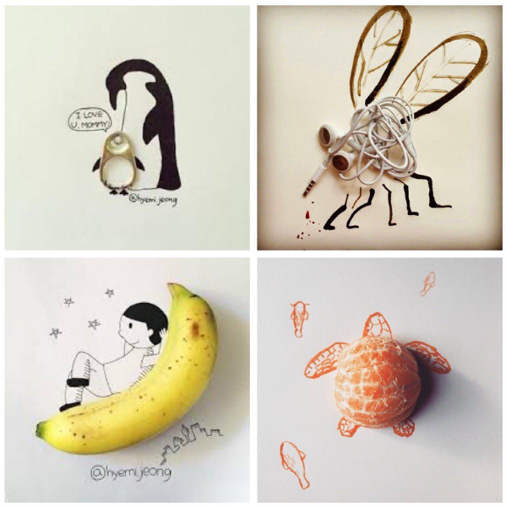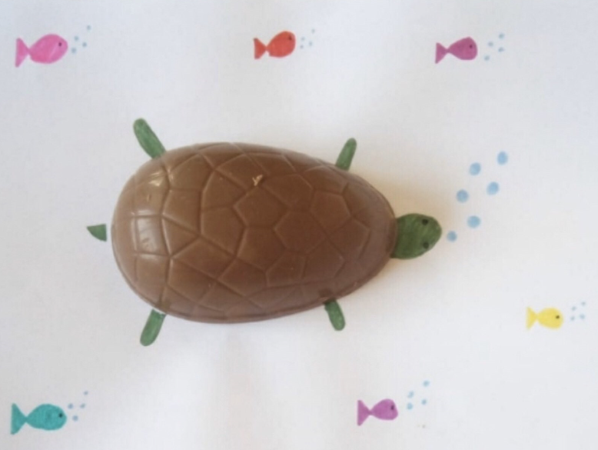

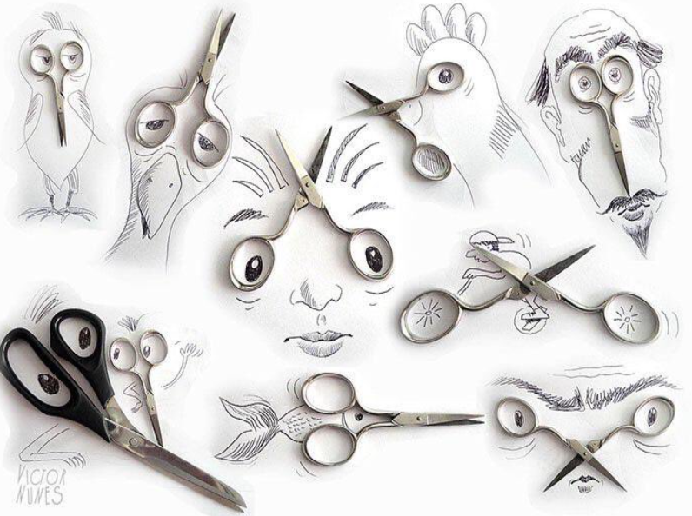

Paper 8: Maths

**Solve the maths problems**

1. Crossing the River

A farmer is trying to cross a river. He is taking with him a rabbit, carrots and a fox and he has a small raft. He can only bring 1 item a time across the river because his raft can only fit either a rabbit, the carrots or the fox. How does he cross the river? (You can assume that nothing is eaten or escapes!)

**3 marks**

1. You are driving a bus to West Ashton School. You drive through Bradford and pick 1 child up, you drive through Trowle Common and pick 1 child up, you drive through Broadmead and pick 5 children up, you drive through Studley Green and pick 4 children up. You drive through Yarnbrook and pick up 10 children. 6 children get off because they decide to walk the rest of the way. Before reaching school, you pick up 14 children from Paxcroft Mead. Who is the bus driver?

**1 mark**

1. How many squares are in the picture?



**3 marks**

Paper 9: Reading

**Name the books using the emoji clue**

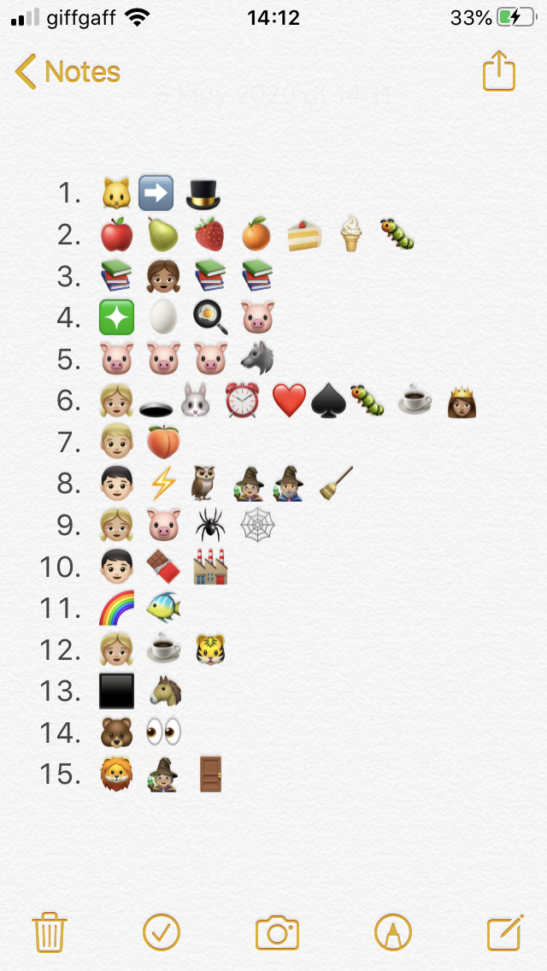

**1 mark**

**1 mark**

**1 mark**

**1 mark**

**1 mark**

**1 mark**

**1 mark**

**1 mark**

**1 mark**

**1 mark**

**1 mark**

**1 mark**

**1 mark**

**1 mark**

**1 mark**

Paper 10: Secondary School

**Visit your secondary school’s website and answer the following questions.**

1. What is your secondary school’s website?

**1 mark**

2. What is the motto or key values?

**1 mark**

3. What is the principal/ head teacher’s name?

**1 mark**

4. Does your secondary school have house groups?

**1 mark**

5. Name 3 exciting facts.

**3 marks**

6. Draw the school logo.

**1 mark**

7. What is the school uniform?

**1 mark**

8. Do they have a social media page to share information?

**1 mark**

9. Find a quote from a pupil at your secondary school. What do they think of the school?

**1 mark**

10. What sports facilities does your secondary school have?

**1 mark**

Paper 11: End of SATs celebration

**Draw your craziest hairstyle celebration. Your hair style will be assessed by a panel of adjudicators and given a score out of 5 for each area: creativity, artistic style and humour!**

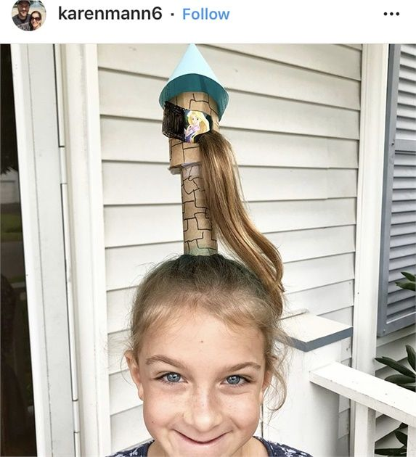**15 marks**

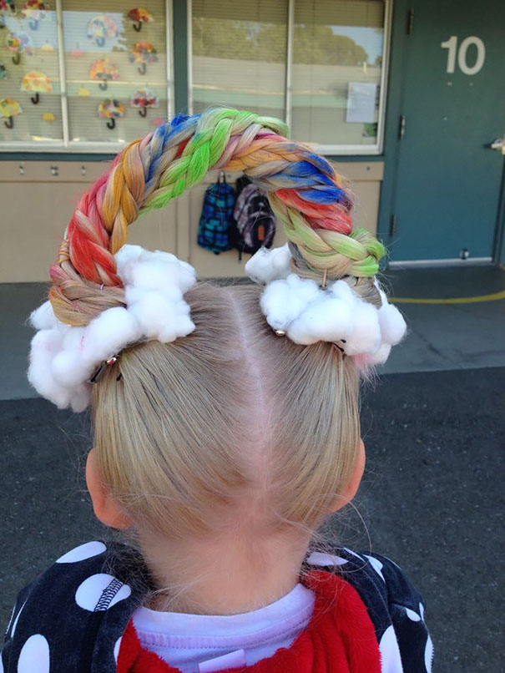

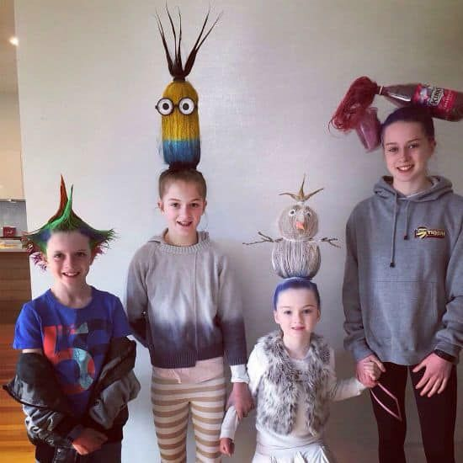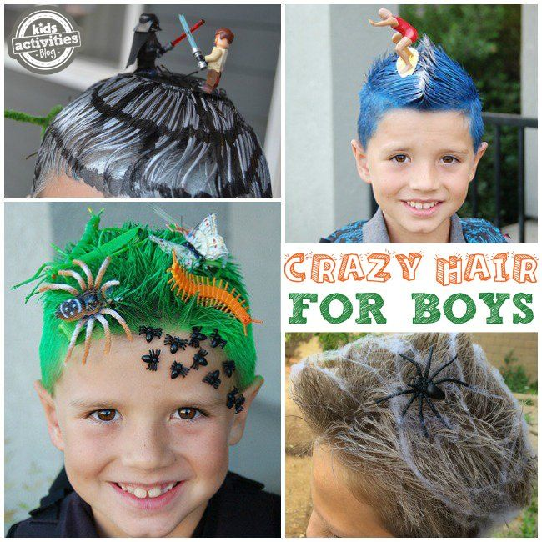

CONGRATULATIONS!

**You have completed the Lockdown SATs – CONGRATULATIONS!**

Voyagers, I am proud of what you have achieved so far in Year 6. It’s a pleasure to teach a class full of amazing individuals. Even though SATs was cancelled, I know how hard you worked during the lead up and nothing will take that away. You are a determined class who are so enthusiastic about learning. Not only that, you work well as a team and support and encourage each other. It’s an absolute pleasure to watch you grow into mature young people with individual qualities and personalities. Although we are not currently at school, we will celebrate your time at West Ashton because no one deserves it more than you!



**Keep smiling and stay positive!**

**Mrs Blake-Thwaite**

***Working hard is important but there is something that matters even more: believing in yourself***