Old Bear by Jane Hissey
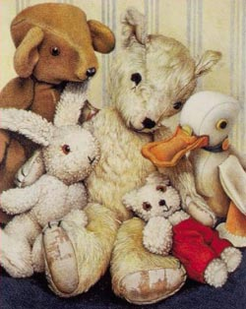
Bramwell Brown was sitting with Duck, Rabbit and Little Bear, when he suddenly remembered someone who wasn’t there.
“I do miss Old Bear,” he said, “I wish he could be here with us.”

A long, long time ago Old Bear was carefully put in a box. Then he was taken up a ladder to the attic.

“The children’s games were a bit too rough,” explained Bramwell “Old Bear was getting worn out.”

“I miss him too,” cried Little Bear. “Let’s go and get him!”

“What a marvellous idea!” said Bramwell Bear.

“We don’t have a ladder,” said Duck.

“We’ll make a tower of bricks,” cried Little Bear thoughtfully, “and climb up to rescue Old Bear”.

The toys collected wooden blocks and piled them up one on top of another.

The tower grew taller and taller. Little Bear was right on top when the tower began to wobble.

“Look out!” he cried, “I’m coming down!”

CRASH!

The tower collapsed all over the floor. “I don’t think you meant to come down that fast!” said Bramwell Brown.

(Page 1)

Title: Word Meaning

Old Bear page 1

- What does the word rough mean in the sentence below?

The children were being too rough with him.

………………………………………………………………………………..
- Find and copy the word that tells you that the tower fell down.

…………………………………………………………………………………
- Match these words up to the correct definition.

marvellous |  | quickly
thoughtfully |  | wild
suddenly |  | wondering
rough |  | brilliant

Extension- Write three word meaning questions about page 1 to show your understanding.

