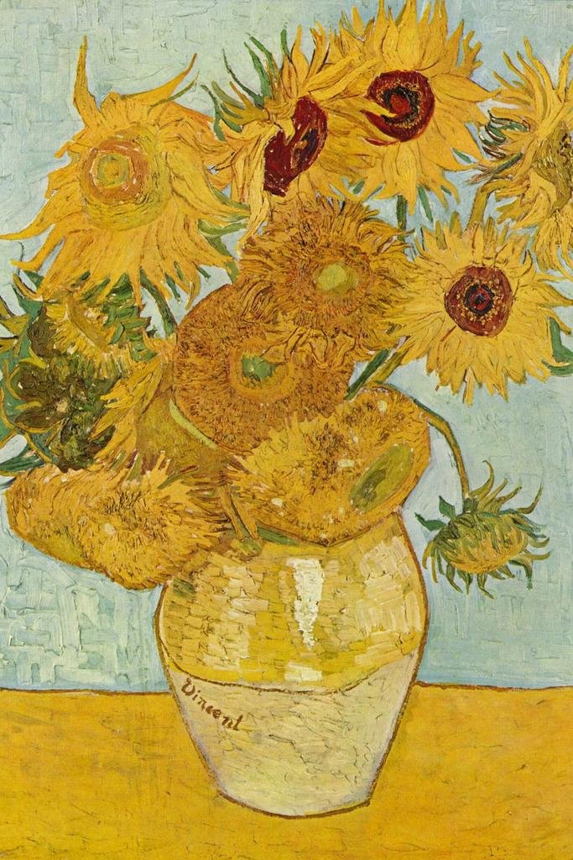

**Math**

In Math the children will continue to develop counting skills and number recognition through daily focused math sessions focusing on maths mastery. The children will explore numbers, number systems and continue to develop skills in Space, Shape and Measure by exploring halving and doubling. .

**Understand the World**  Children will explore the learning environment each week where they will be encouraged to take part in planning in the moment, developing on their own interests, knowledge and experiences. Through the class topic children will explore Van Gogh’s painting ‘Sunflowers’ whilst developing knowledge of the wonder of specific insects. Children will be encouraged to explore the wonder of art and the insect world, discovering connections of how they might be linked, and using these connections to develop skills, passions and understanding of the world.

**PSED**

Personal, Social and Emotional Development will focus on self-confidence and self-awareness, as we begin to prepare children for transition into reception and year one. Children will be encouraged to further develop independence, find their own voice, and have their own views and opinions.

**Literacy**

In Literacy We will continue to develop phonic knowledge as we embed Phase 2, 3 and 4 letters and sounds and continue to focus on tricky words. We will be continuing to build a sentence using our phonic knowledge and be focusing on letter formation and handwriting. We will enhance our passion for reading through our class topic and continue reading and sharing books with you at home. whilst focusing on speaking, listening and independent writing skills

**Physical Development**

Children will continue to develop fine and gross motor skills through focused PE sessions (managed by trained PE instructors within the Acorn Academy Trust), and through the use of manipulatives within the classroom environment, aiming to give the children the skills required to effectively control their body movements in order to develop tricky skills e.g. pencil control.

**Pioneers class summer Term 2 topic web!**

Art Attack

**RE**

This term focuses on special places and homes around the world. Children will be encouraged to develop knowledge of the church, mosque and synagogue.

**Communication and Language**

Children will continue to develop communication and language skills through focused activities and free play. A focus will be placed on the child having a voice as they are encouraged to participate in all activities and discussions, developing independence as they prepare for transition into the next year group.

**Expressive Arts and Design**

Children will be given the opportunity to get creative with their imaginations using various role play stimulus, art materials, experimenting with colour, design, texture, form and function. The children will develop knowledge and skills on the safe use of materials, tools and techniques whilst creating their masterpieces focused on topic work and festivals. .