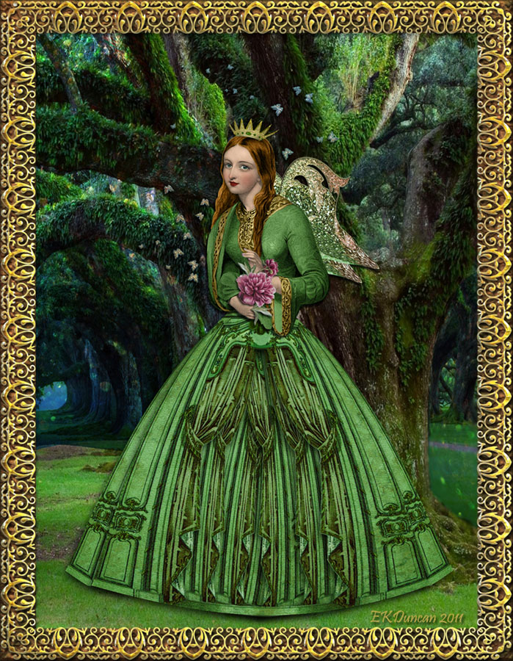

**Math**

In Math the children will continue to develop counting skills and number recognition through daily focused math sessions.

The children will explore numbers, number systems and continue to develop skills in Space, Shape and Measure.

**Understand the World**  Children will explore the learning environment each week where they will be encouraged to take part in planning in the moment, developing on their own interests, knowledge and experiences. Through the class topic children will discover the land of fairy tales and become immersed in the magic and wonder of traditional tales. The stories will help develop a growing knowledge of plants and animals and the world in which we live.

**PSED**

Personal, Social and Emotional Development will focus on health and self-care, as we encourage children to be independent with self-care, have a sense of what it means to keep healthy and to look after our bodies.

**Literacy**

In Literacy We will continue to develop phonic knowledge as we embed Phase 2 and 3, letters and sounds and continue to focus on tricky words. We will be focusing on building a sentence using our phonic knowledge and will practice letter formation. We will enhance our passion for reading through our class topic and continue reading and sharing books with you at home. whilst focusing on speaking and listening skills.

**Pioneers class Spring Term 2 topic web!**

**‘Once upon a time’**

**Physical Development**

Children will continue to develop fine and gross motor skills through focused PE sessions (managed by trained PE instructors within the Acorn Academy Trust), and through the use of manipulatives within the classroom environment, aiming to give the children the skills required to effectively control their body movements in order to develop tricky skills e.g. pencil control.

**Expressive Arts and Design**

Children will be given the opportunity to get creative with their imaginations using various role play stimulus, art materials, experimenting with colour, design, texture, form and function. The children will develop knowledge and skills on the safe use of materials, tools and techniques whilst creating their masterpieces focused on topic work and festivals. .

**RE**

The children will be developing knowledge on why we celebrate Easter. The children will gain an understanding of why we put a cross in the Easter garden.

**Communication and Language**

Children will continue to develop communication and language skills through focused activities and free play. A focus will be placed on the child having a voice as they are encouraged to participate in all activities and discussions.