Old Bear – Monday reading (Page 4)

Little Bear packed the parachutes and a torch in his bag. Bramwell wound up the propeller of the little plane.
“Five, four, three, two, one, go!. They whizzed along the carpet and up into the air. As they passed the trapdoor Little Bear pushed it open with a paintbrush.

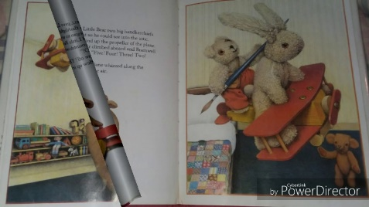
“Fly past again!” he called to Rabbit. “I’ll jump in!” Bramwell gasped as Little Bear grabbed the edge of the trapdoor and pulled himself inside.

It was very dark in the attic so he turned on his torch.
“Any bears in there?” he whispered.
Then he heard a little “Grrrr” and there was Old Bear, sitting by a box, covered in dust.

“Old Bear! Old Bear!” squeaked Little Bear. “We have missed you.”

“I’ve missed you too.” said Old Bear.
(Page 4)

Title: Retrieval
Old Bear – Page 4

- Which part of the trap door did Little Bear hold onto?

- Which two of the following adjectives does the author use to describe the attic?
smelly dark lonely busy quiet

- Find and copy the word that tells you what noise Little Bear first heard in the attic.

- Write down three things that you can see in the attic in the illustration below.

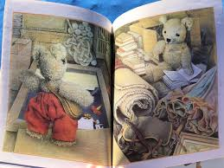

- What did Little Bear say to show that he was excited when he found Old Bear?

