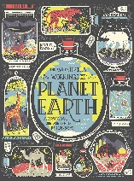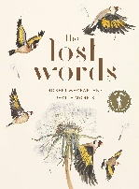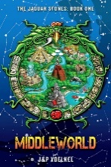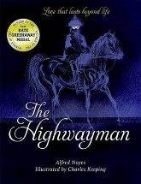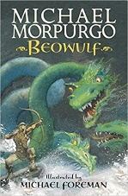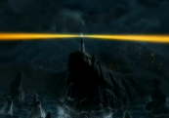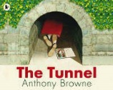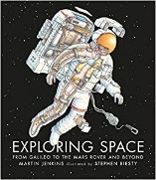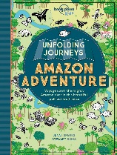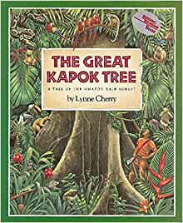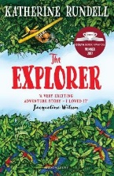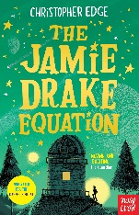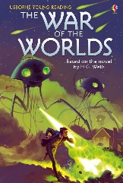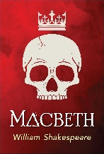

Voyagers writing outcomes and texts plus class reads

Year A

Newspaper article

Review

Advertising

Letter

Campaign

Poetry

Report

Character /settings

Diary

Suspense

Report

Character /settings

Description

Balanced argument

Letter

Campaign

Newspaper article

Character /settings

Description

Mystery

Speech

Balanced argument

Character /settings

Description

Adventure

Report

Letter

Newspaper article

Character /settings

Diary

Poetry

Character

Poetry

Diary

Newspaper article

Character /settings

Description

Legend

Poetry

To discuss

To persuade

To entertain

To inform

Warming warning!

Forces & forests

Infinity & beyond!

Down Mexico way

Dark and greedy?

Summer 1

Spring 2

Autumn 1

Spring 1

Summer 2

Autumn 2