English  This term we will be studying the text- ‘The Firework -Makers Daughter’ by Philip Pullman. We will be reading every day in class focussing on expression, fluency and punctuation when reading aloud. We will read with a partner to retrieve and infer.  Linked to our WW2 topic, we will be writing;  A Remembrance assembly, Firework poetry linked to text, Instructions- How to make an Anderson Shelter. Letters from evacuees, rationing recipes, a non-chronological report on The Role of women in WW2.  Please continue to practice spellings at home and to read every day. |  | Maths  Addition and subtraction  Add and subtract numbers with up to three (Y3) or four (Y4) digits, using formal written methods of column addition and subtraction. Estimate the answer to a calculation and use inverse operations to check answers  Solve addition and subtraction two-step problems in contexts, deciding which operations and methods to use and why.  Multiplication and Division  Y3 count in multiples of 3, 4, 8, recall and use multiplication and division facts for the 3, 4 and 8 multiplication tables.  Y4 count in multiples of 6, 7, 9, recall multiplication and division facts for multiplication tables up to 12 × 12. Multiply two-digit and three-digit numbers by a one digit number using formal written layout.
Science  This term we will continue our learning about animals, their habitats and the threats they face. We will be watching and learning from  Seven Worlds, One Planet  Please try to watch on Sunday evenings on BBC1. We will find out about the scientist and conservationist Sir David Attenborough.  Geography  use maps, atlases, globes and digital/computer mapping to locate countries and continents. | Discoverers  WORLD WAR TWO  Term 2 2019  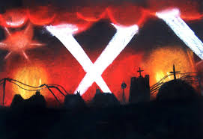  conflict power duty forgiveness fear | 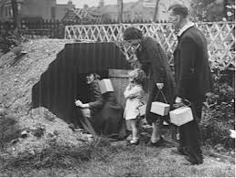 | RE  I can explain the meaning and main beliefs of the Trinity  I can create my own hymns and art work to celebrate the Trinity.
 |  | PE  Netball and dance with Miss Davies. Please ensure appropriate kit for indoor and outdoor PE is in school. | Music  Singing with Mrs Heywood-  - Remembrance  - Christmas  - Young Voices
DT  We will design and make an Anderson shelter.  We will find out all about rationing and use some recipes to create a wartime meal.  Computing  Typing skills. | History  We will learn when and why World War II began and find out about the key individuals and countries involved. We will:  - discover all about evacuation;  - learn what it was like to live with food rationing  - explore the contribution made by women to the war effort.  - learn important facts about the Holocaust and  - investigate the blitz  Studying World War II will help children to develop their investigation and evaluation skills; learn to organise information chronologically and understand how past events have helped to shape the world we know today.

