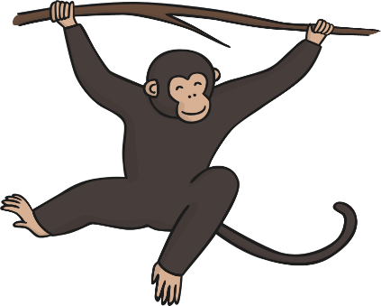
What can we find in our rainforests?
Plants | Insects
Mammals | Birds

