The Little Shoemaker
https://www.youtube.com/watch?v=fEUwBMThY1w
Year 3 Home Learning Task
Group 2 ( in school Wednesday to Friday)
Ready for Wednesday, watch the video The Little Shoemaker; a film about a shoemaker called Mr Botte. He makes and sells unusual shoes and business is good. However, the little shoemaker's life is about to change... a new shoe seller is in town and he will do anything to gain business. Mr Botte's business starts to fail. How will he cope? Maybe he will get some help from some special helpers…

Your task:
Monday Watch the film
- Design a poster advertising Mr Botte’s shoe shop.
You will need to use persuasive language to encourage lots of customers.

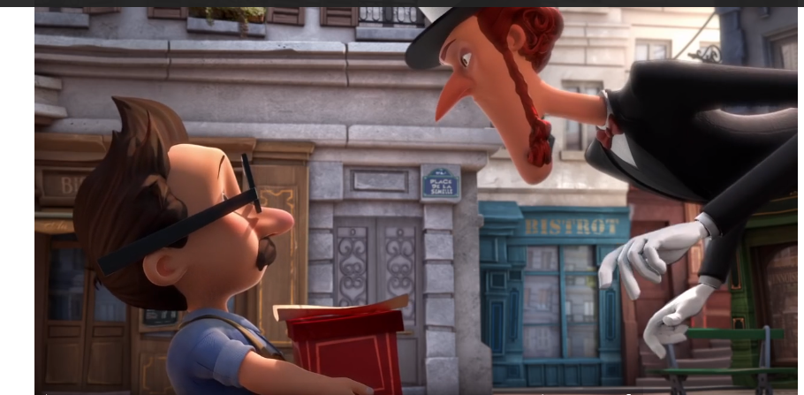
- Create some dialogue between the two characters – what are they saying to each other?

Tuesday 1. Design a pair of magic shoes. Draw and label each of the features of the shoes.
- Write some instructions on how to make the shoes.

